**WEB PROGRAMMING**

**LAB RECORD**

ANJU PAUL

S1 MCA

MCA/693/21

**EXPERLMENT :1**

**HTML PROGRAM USING BASIC TAGS**

**AIM**

To write a html program using basic html tags

**Source code**

<!doctype html>

<html>

<title>html</title>

<body>

<h1><b><center><font color="naviblue">SCMS SCHOOL OF ENGINEERING AND TECHNOLOGY</font></center></b></h1>

<body bgcolor="lavender">

<p>SCMS School of Engineering and Technology (SSET) is envisaged as a premier institution

offering technology related education of exceptional quality to students by developing their

total personality with due emphasis on ethical values and preparing them to meet the growing challenges of the industry

and diverse societal needs of the institution.</P><br>

<center><img src = "college.jpeg" width="800",height="400" alt = "image of college" /></center>

<a href="https://www.scmsgroup.org/sset/"><i>link text</i></a>

<p>The SCMS School of Engineering & Technology (SSET), promoted by the SCMS Group of Educational Institutions,

has been in the forefront of providing quality professional education in Engineering & Technology since 2001.</p><br>

<blockquote><p>"The SSET has established state of the art facilities on a sprawling 29 acre campus at Karukutty in Ernakulam District.

SSET is one among the first ten colleges to be set up in the State under the private self-financing scheme."

</blockquote></p>

<h3>courses</h3>

<ol>

<li>mca</li>

<li>b.tech</li>

<li>m.tech</li>

</ol>

**OUTPUT**

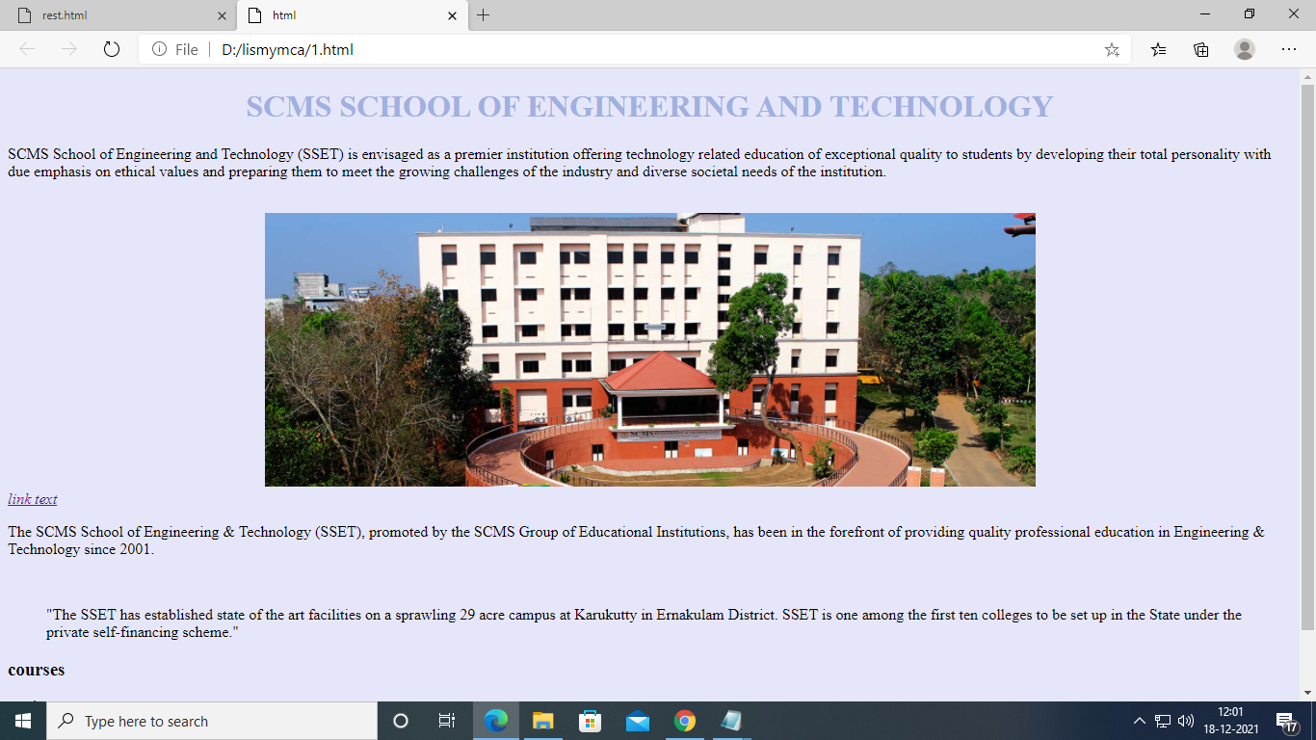

**EXPERLMENT :2**

**IMAGE MAPPING**

**AIM**

To create a web page using html by including the following things

1. To embed an image map in the web page
2. To fix the hotspot
3. Show all related information when hotspot is checked.

**Source code**

**Solarsystem.html**

<! DOCTYPE html>

<html>

<body bgcolor="black">

<h1><center><font color="yellow"> solar system </font></center><h1>

<h2>Image maps</h2>

<p><font color=white>The Solar System is a group of planets, dwarf planets asteroids and comets that orbit around the Sun. The planets in the Solar System include Mercury,venus, Earth, Mars, Jupiter, Saturn, Uranus, and Neptune.</fond></p>

<img src="D:\webproanju\solar3.jfif" alt="solar3" usemap="#solarmap" width="500" height="500">

<map name="solarmap">

<area shape="circle" coords="0,250,60" alt="sun" href="sun.html">

<area shape="circle" coords="108,245,10" alt="Mercury" href="Mercury.html">

<area shape="circle" coords="140,245,15" alt="venus" href="venus.html">

<area shape="circle" coords="180,245,20" alt="earth" href="earth.html">

</map>

</body>

</html>

**OUTPUT**

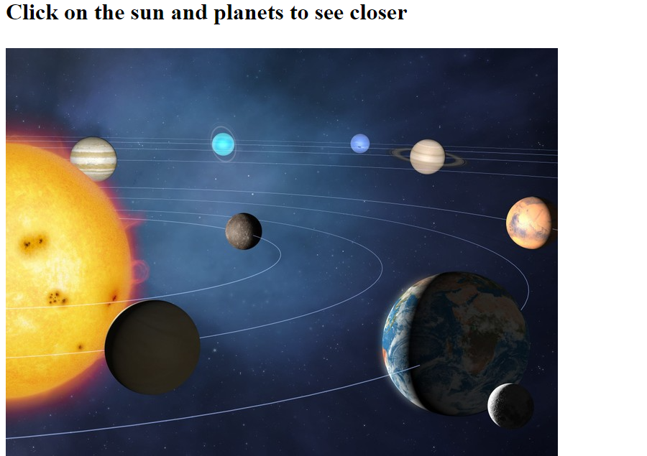

**sun.html**

<! DOCTYPE html>

<html>

<body bgcolor="black">

<h1><center><font color="yellow"> sun </font></center><h1>

<p><font color=white>The Sun is a yellow dwarf star, a hot ball of glowing gases at the heart of our solar system. Its gravity holds everything from the biggest planets to tiny debris in its orbit.</font></p>

<img src="D:\webproanju\sun.jfif" alt="solar3" usemap="#solarmap" width="500" height="500">

</body>

</html>

**OUTPUT**

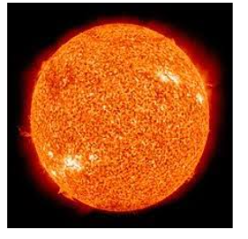

**Mercury.html**

<! DOCTYPE html>

<html>

<body bgcolor="black">

<h1><center><font color="yellow"> mercury </font></center><h1>

<p><font color=white>The Sun is a yellow dwarf star, a hot ball of glowing gases at the heart of our solar system. Its gravity holds everything from the biggest planets to tiny debris in its orbit.</font></p>

<img src="D:\webproanju\mercury.jfif" alt="solar3" usemap="#solarmap" width="500" height="500">

</body>

</html>

**OUTPUT**

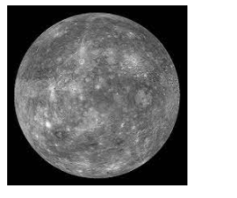

**Venus.html**

<! DOCTYPE html>

<html>

<body bgcolor="black">

<h1><center><font color="yellow"> venus </font></center><h1>

<p><font color=white>Venus spins slowly in the opposite direction from most planets. A thick atmosphere traps heat in a runaway greenhouse effect, making it the hottest planet in our solar system..</font></p>

<img src="D:\webproanju\venus.jfif" alt="solar3" usemap="#solarmap" width="500" height="500">

</body>

</html>

**OUTPUT**

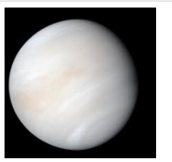

**Earth.html**

<! DOCTYPE html>

<html>

<body bgcolor="black">

<h1><center><font color="yellow"> Earth </font></center><h1>

<p><font color=white>Earth—our home planet—is the only place we know of so far that’s inhabited by living things. It's also the only planet in our solar system with liquid water on the surface.</font></p>

<img src="D:\webproanju\earth.jfif" alt="solar3" usemap="#solarmap" width="500" height="500">

</body>

</html>

**OUTPUT**

**EXPERLMENT :3**

**Inline style sheet**

**AIM**

To create an html document which displays the details of different cars(Use inline styling)

**Source code**

car.html

<html>

<head><title>Cars</title></head>

<body>

<h1 align="center" style="color:#800000;">DIFFERENT TYPE OF CARS</h1>

<div style="background-color:#FFA500;color:black;padding:40px;">

<h2 style="color:#DB7093;">Mahindra Thar</h2>

<p style="color:white;">The Diesel engine is 2184 cc while the Petrol engine is 1997 cc .

It is available with Manual & Automatic transmission.

Depending upon the variant and fuel type the Thar has a mileage

of & Ground clearance of Thar is 226mm. The Thar is a 4 seater 4 cylinder car</p>

<img src="thar.jpeg" width="200px" height="100px">

</div>

<div style="background-color:#B0C4DE;color:black;padding:40px;">

<h2 style="color:#DB7093;">buggatti vegronCars</h2>

<p style="color:#000080;">The fourth Bugatti on our list, the standard Veyron, is the first production car that surpassed the 250-mph mark.

And it did it back in 2005 when it put an end to McLaren’s long-standing record set with the F1 in 1993.

The Veyron, fitted with an early version of the 8.0-liter W-16, hit a top speed of 253.8 mph on April 19, 2005.</p>

<img src="buggatti vegronCars.jpg" width="200px" height="100px">

</div>

<div style="background-color:#005757;color:black;padding:40px;">

<h2 style="color:#DB7093;">McLaren Automotives</h2>

<p style="color:white;">McLaren Automotive is a British automotive manufacturer based at the McLaren Technology Centre in Woking, England.

The main products of the company are supercars, which are produced in-house in designated production facilities. In July 2017,

McLaren Automotive became a 100% owned subsidiary of the wider McLaren Group.</p>

<img src="McLaren Automotives.jpg" width="200px" height="100px">

<div>

</body>

</html>

**OUTPUT**

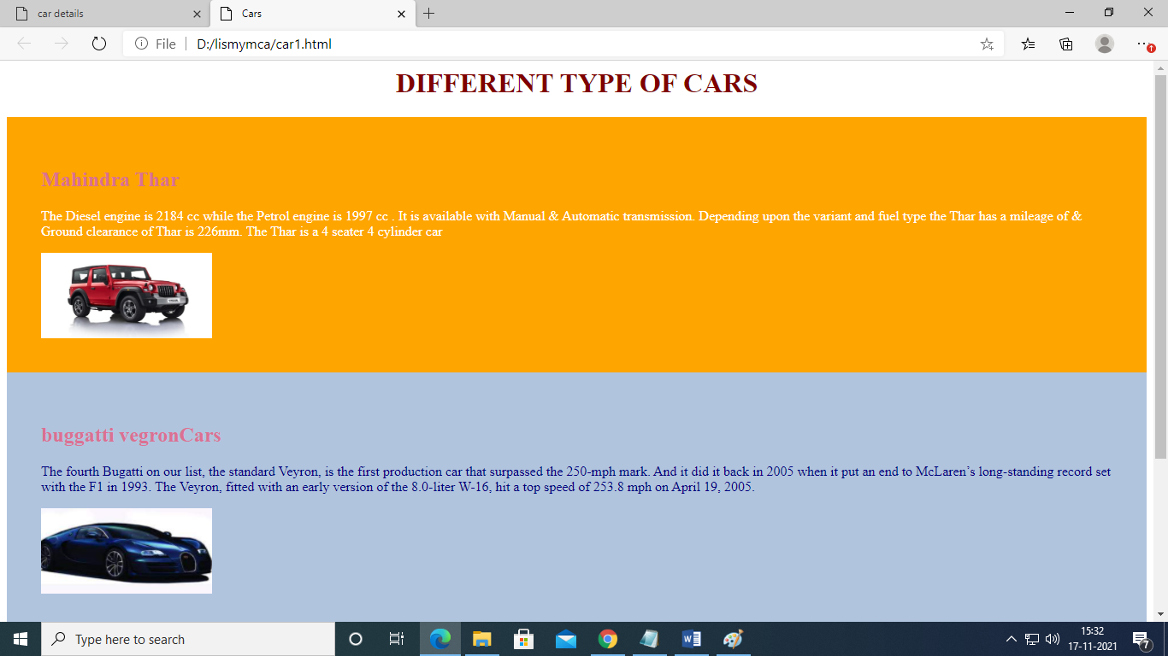

**EXPERLMENT :4**

**Internal style sheet**

**AIM**

To create a webpage using internal style sheet(College site)

**Source code**

<!DOCTYPE html>

<html>

<head>

<style>

div.one {

background-color:#00008B;

height: 20px;

weight: 100%;

color: white;

padding: 15px;

cursor: pointer;

}

.one a{

text-decoration: none;

color: white;

}

.one a:hover{ color: red;}

div.two{

color:white;

font-family: "Times New Roman", Times, serif;

background-color:#e52b50;

top: 30px;

height:30px;

width: 400px ;

padding: 25px 25px 25px 25px;

margin:0px 0px 0px 700px;

text-align:left;

}

div.three {

background-color:#800020;

height: 30px;

width: 100%;

color: white;

padding: 16px;

cursor: pointer;

}

div.four {

background-color:#D2042D;

height: 20px;

width: 100%;

color: white;

padding: 15px;

cursor: pointer;

}

div.five {

background-color:#800020;

height: 20px;

width: 100%;

color: white;

padding: 15px;

}

div.six {

background-color:#D2042D;

height: 20px;

width: 100%;

color: white;

padding: 15px;

cursor: pointer;

}

div.seven{ background-color:#02055A ;

top:30px;

width: 148px;

height: 32px;

color:white;

text-align:center;

font-family: "Times New Roman", Times, serif;

}

div.eight{ background-color:white;

height: 80px;

width: 100%;

color:black;

font-family: "Times New Roman", Times, serif;

text-align: center;

padding-top:20px;

}

.dropdown {

position: relative;

display: inline-block;

}

.bottom{

position:absolute;

bottom:100px;

center:500px;

color:white;

font-size:20px;

}

.dropbtn {

background-color: #800020;

color: white;

padding: 14px;

font-size: 14px;

border: none;

}

.dropbtn a{

text-decoration: none;

color: white;

}

.dropdown-content {

display: none;

position: absolute;

background-color:#800020;

min-width: 300px;

box-shadow: 0px 8px 16px 0px rgba(0,0,0,0.2);

z-index: 1;

}

.dropdown-content a {

color: black;

padding: 12px 16px;

text-decoration: none;

display: block;

}

.dropdown-content a:hover {background-color: white;}

.dropdown:hover .dropdown-content {display: block;}

.dropdown:hover .dropbtn {background-color: #800020;}

.dropbtn a:hover{ color: red;}

</style>

</head>

<body>

<div class=one>

<a href="https://www.scmsgroup.org/sset/">sset@scmsgroup.org</a>

<font color="red">.</font>

<a href="https://www.scmsgroup.org/sset/downloads/SCMS%20School%20of%20Engineering%20-%20%20Admission%20Brochure%202020-21.pdf">download admission brochure </a>

&nbsp&nbsp&nbsp&nbsp&nbsp&nbsp&nbsp&nbsp&nbsp&nbsp&nbsp&nbsp&nbsp&nbsp&nbsp&nbsp&nbsp&nbsp&nbsp&nbsp&nbsp

&nbsp&nbsp&nbsp&nbsp&nbsp&nbsp&nbsp&nbsp&nbsp&nbsp&nbsp&nbsp&nbsp&nbsp&nbsp&nbsp&nbsp&nbsp&nbsp&nbsp&nbsp&nbsp&nbsp&nbsp&nbsp&nbsp&nbsp&nbsp&nbsp&nbsp&nbsp&nbsp&nbsp&nbsp&nbsp&nbsp&nbsp&nbsp&nbsp

&nbsp&nbsp&nbsp&nbsp&nbsp&nbsp&nbsp&nbsp&nbsp&nbsp&nbsp&nbsp&nbsp&nbsp&nbsp&nbsp&nbsp&nbsp&nbsp&nbsp&nbsp&nbsp&nbsp&nbsp&nbsp&nbsp&nbsp&nbsp&nbsp&nbsp&nbsp&nbsp&nbsp&nbsp&nbsp&nbsp&nbsp&nbsp&nbsp&nbsp&nbsp&nbsp&nbsp&nbsp&nbsp

&nbsp&nbsp&nbsp&nbsp&nbsp&nbsp&nbsp&nbsp&nbsp&nbsp&nbsp&nbsp&nbsp&nbsp&nbsp&nbsp&nbsp&nbsp&nbsp&nbsp&nbsp

<font color="red"> .</font>

<a href="https://www.scmsgroup.org/sset/onlinefeepayment">online payment</a>

<font color="red"> .</font>

<a href="https://scmsgroup.org/sset/admission">Admissions 2021 </a>

<font color="red">.</font>

<a href="https://www.scmsgroup.org/sset/career">career</a>

<font color="red">.</font>

<a href="https://www.scmsgroup.org/sset/contact">contact us</a>

</div>

<div class=eight>

<img src="https://www.scmsgroup.org/sset/images/logo-hm.png" align="left">

<div class=two>Admission hotline : 70347 80074 ,70347 80073, 70347 80072<div class=seven> College code :SCM</div></div></div>

` <div class=three>

<div class="dropdown">

<button class="dropbtn"><a href="#">Home </a> </button>

</div>

<div class="dropdown">

<button class="dropbtn"><a href="#">About us </a> </button>

<div class="dropdown-content">

<a href="https://www.scmsgroup.org/sset/web/aboutus">Vission & Mission</a>

<a href="https://www.scmsgroup.org/sset/web/sset_objective">SSET Objectives</a>

<a href="#">Recognition & Affiliation</a>

<a href="#">SSET Objectives</a>

<a href="#">Management</a>

<a href="#">Director's Profile & Message</a>

<a href="#">Principle's Profile & Message</a>

<a href="#">Sailent Features</a>

<a href="#">Awards & Accolades</a>

<a href="#">Grevience Redressal Committee</a>

<a href="#">IQAC committee</a>

<a href="#">Internal Complaints Committee</a>

<a href="#">SC/ST Monitoring Committee</a>

<a href="#">Regulations & Directives-Anti Ragging</a>

<a href="#">AICTE Elements</a>

<a href="#">Accreditation</a>

<a href="#">NIRF 2021</a>

<a href="#">Statutory Declaration</a>

</div></div>

<div class="dropdown">

<button class="dropbtn"><a href="#">Departments</a> </button>

<div class="dropdown-content">

<a href="">Automobile Engineering</a>

<a href="">Basic Science & Humanities</a>

<a href="#">Civil Engineering</a>

<a href="#">Computer Science & Engineering</a>

<a href="#">Electrical & Electronics Engineering</a>

<a href="#">Electronics & Communication Engineering</a>

<a href="#">Mechanical Engineering</a>

<a href="#">Administration</a>

</div></div>

<div class="dropdown">

<button class="dropbtn"><a href="#">Academics </a> </button>

<div class="dropdown-content">

<a href="#">B.Tech</a>

<a href="#">M.Tech</a>

<a href="#">MCA</a>

</div></div>

<div class="dropdown">

<button class="dropbtn"><a href="#">NAAC&nbsp </a> </button>

<div class="dropdown-content">

<a href="">IQAC at SSET</a>

<a href="">AQAR 2015-2016</a>

<a href="#">AQAR 2016-2017</a>

<a href="#">AQAR 2017-2018</a>

<a href="#">AQAR 2018-2019</a>

<a href="#">AQAR 2019-2020</a>

<a href="">B.Tech</a>

<a href="">M.Tech</a>

<a href="#">MCA</a>

</div></div>

<div class="dropdown">

<button class="dropbtn"><a href="#">Placements </a> </button>

<div class="dropdown-content">

<a href="">Overview</a>

<a href="">MoU'S</a>

<a href="#">Training</a>

<a href="#">R</a>

<a href="#">AQAR 2018-2019</a>

<a href="#">AQAR 2019-2020</a>

<a href="">B.Tech</a>

<a href="">M.Tech</a>

<a href="#">MCA</a>

</div></div>

<div class="dropdown"><button class="dropbtn"><a href="https://www.google.com">Campus</a></button>

<div class="dropdown-content">

<a href="">Overview</a>

<a href="">System of Teaching</a>

<a href="#">Soft skills and Personality Development</a>

<a href="#">counselling and Guidance</a>

<a href="#">Facilities</a>

<a href="#">Sewage Treatment Plant</a>

</div>

</div>

<div class="dropdown"><button class="dropbtn"><a href="https://www.google.com">Research</a></button>

<div class="dropdown-content">

<a href="">Dr.PPT Learning Resource Centre</a>

<a href="">SCMS Water Institute</a>

<a href="#">Research Cell</a>

<a href="#">IEDC-SSET </a>

<a href="#">Dr. PPT Innovation Awards</a>

<a href="#">SCMS Centre for Robitics</a>

<a href="#">NPTEL: SSET Local chapter</a>

</div>

</div>

<div class="dropdown"><button class="dropbtn"><a href="https://www.google.com">News & Events</a></button>

<div class="dropdown-content">

<a href="">News Updates</a>

<a href="">SCMS News Letter</a>

<a href="#">Media</a>

<a href="#">Photo Gallery</a>

</div>

</div>

<div class="dropdown"><button class="dropbtn"><a href="https://www.google.com">Campus Life</a></button>

<div class="dropdown-content">

<a href="">Overview</a>

<a href="">Sports</a>

<a href="">NSS</a>

<a href="">Helping Hands Organizaion</a>

<a href="">Arts</a>

<a href="">Staff Recreation</a>

<a href="">IEEE Students Branch</a>

<a href="">KBA Innovation Club</a>

<a href="">College Union</a>

<a href="">Computer Science-SYNERGY</a>

<a href="">Electronics- EXPLORA</a>

<a href="">Electrical-ACE</a>

<a href="">Civil- ICI SSET</a>

<a href="">Automobile- SAEINDIA</a>

<a href="">Automobile- TORQUE</a>

<a href="">Civil Frames</a>

<a href="">Mechanical- ARME</a>

</div>

</div>

<div class="dropdown"><button class="dropbtn"><a href="https://www.google.com">Alumni</a></button>

<div class="dropdown-content">

<a href="https://www.scmsgroup.org/sset/alumni-overview">Alumni Overview</a>

<a href="https://www.scmsgroup.org/sset/alumni-association-Enosis">Alumni Association - Enosis</a>

<a href="https://www.scmsgroup.org/sset/organization-department-coordinators">Organization & Department Coordinators</a>

<a href="https://www.scmsgroup.org/sset/alumni-chapters">Alumni Chapters</a>

<a href="https://www.scmsgroup.org/sset/alumni-events-activites-guest-lectures">Alumni Events/Activities & Guest Lectures</a>

<a href="https://www.scmsgroup.org/sset/prominent-alumni">Prominent Alumni</a>

<a href="https://www.scmsgroup.org/sset/alumni-start-ups">Alumni Start-ups</a>

</div>

</div>

<div class="dropdown"><button class="dropbtn"><a href="https://www.google.com">Login</a></button>

<div class="dropdown-content">

<a href="https://sset.linways.com/student/parent.php">Parents Login</a>

<a href="https://sset.linways.com/student/">Students Login</a>

<a href="https://ssetalumni.org/">Alumni Login</a>

<a href="https://sset.linways.com/staff/">Staff Ecoleaide-Login</a>

<a href="https://sset.linways.com/staff/">Staff Email - Login</a>

</div>

</div>

<div class=four>

<marquee>SSET B.Tech Admissions 2021 | SSET Academic Excellence Award | SSET MTech Admissions 2021</marquee>

</div>

<img src="https://www.scmsgroup.org/sset/uploads/homepage_banner/thumb/ssetcollage1_jpg.png">

<div class=five>

<center>Our NBA Accredited Courses : Computer Science & Engineering, Mechanical Engineering & Civil Engineering</center>

</div>

<div class=six><marquee>KTU Exams 2021 - WAR ROOM | Seating Arrangements ESE 2021</marquee></div>

<h3><font color="red">SCMS School of Engineering and Technology Core Values of SSET</font></h3>

<UL><font color="black">

<LI>Embrace an environment that fosters realisation of individual potential and encourages self-discovery</LI>

<LI>Problem-solving through creative and critical thinking</LI>

<li>Nurture values of trust, integrity, fairness, and respect to be responsible citizens</li>

<li>Treating all as equals by embracing individual differences in ideas, cultures, and communities</li></font>

</UL>

<h3><font color="red">SCMS School of Engineering & Technology</font></h3>

<p><font color="black">SCMS School of Engineering and Technology (SSET) is envisaged as a premier institution offering technology related education of exceptional quality

to students by developing their total personality with due emphasis on ethical values and preparing them to meet the growing challenges of the

industry and diverse societal needs of the institution.</font></p>

<p><font color="black">The SCMS School of Engineering & Technology (SSET), promoted by the SCMS Group of Educational Institutions, has been in the forefront of providing

quality professional education in Engineering & Technology since 2001. The SSET has established state of the art facilities on a sprawling 29 acre

campus at Karukutty in Ernakulam District. SSET is one among the first ten colleges to be set up in the State under the private self-financing scheme.

Right from the beginning SSET concentrated on providing quality education in a highly disciplined environment. This has paid rich dividends over the past

years as is evident from the preference of students to join the College</font></p>

</body>

</html>

**OUTPUT**

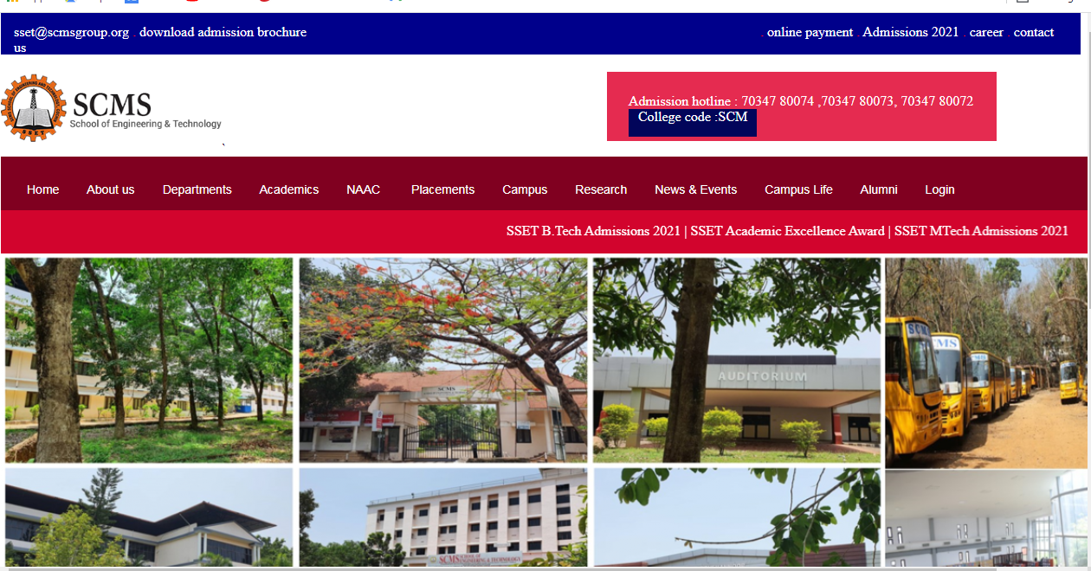

**EXPERLMENT :5**

**AIM**

To create a webpage using external style sheet(Restuarent site)

**Source code**

res.html

<html>

<head>

<link rel="stylesheet" href="mystyle1.css">

</head><body><div class="logo">

<p>

<h1><center><a>Restaurant</a></center></h1></div>

&nbsp;&nbsp;&nbsp;&nbsp;&nbsp;&nbsp;&nbsp;&nbsp;&nbsp;&nbsp;&nbsp;&nbsp;&nbsp;&nbsp;&nbsp;&nbsp;&nbsp;&nbsp;&nbsp;&nbsp;&nbsp;&nbsp;&nbsp;&nbsp;&nbsp;&nbsp;&nbsp;&nbsp;&nbsp;&nbsp;&nbsp;&nbsp;&nbsp;&nbsp;&nbsp;&nbsp;&nbsp;&nbsp;&nbsp;&nbsp;&nbsp;&nbsp;&nbsp;&nbsp;&nbsp;&nbsp;&nbsp;&nbsp;&nbsp;&nbsp;&nbsp;&nbsp;&nbsp;&nbsp;&nbsp;&nbsp;&nbsp;&nbsp;&nbsp;&nbsp;&nbsp;&nbsp;&nbsp;&nbsp;&nbsp;&nbsp;&nbsp;&nbsp;&nbsp;&nbsp;&nbsp;&nbsp;&nbsp;&nbsp;&nbsp;&nbsp;&nbsp;&nbsp;&nbsp;&nbsp;&nbsp;&nbsp;&nbsp;&nbsp;&nbsp;&nbsp;&nbsp;&nbsp;&nbsp;&nbsp;&nbsp;&nbsp;&nbsp;&nbsp;&nbsp;&nbsp;&nbsp;&nbsp;&nbsp;&nbsp;&nbsp;&nbsp;&nbsp;&nbsp;&nbsp;&nbsp;

<div class="logo1">

<a href="file:///D:/anjumca/web/resta.html">Home</a>&nbsp;&nbsp;&nbsp;&nbsp;&nbsp;&nbsp;&nbsp;&nbsp;&nbsp;

<a>About us</a>&nbsp;&nbsp;&nbsp;&nbsp;&nbsp;&nbsp;&nbsp;&nbsp;&nbsp;

<a href="https://d4t7t8y8xqo0t.cloudfront.net/resized/1080X/restaurant%2F657364%2Fmenu%2Fmenu01538046030170.jpg">Menu</a>&nbsp;&nbsp;&nbsp;&nbsp;&nbsp;&nbsp;&nbsp;&nbsp;&nbsp;

<a href="https://cdn4.vectorstock.com/i/1000x1000/68/28/restaurant-vertical-color-menu-vector-9946828.jpg">Todays Special</a>

&nbsp;&nbsp;&nbsp;&nbsp;&nbsp;&nbsp;&nbsp;&nbsp;&nbsp;

<a>Contact Us</a>

&nbsp;&nbsp;&nbsp;&nbsp;&nbsp;&nbsp;&nbsp;&nbsp;&nbsp;

<div class="image">

<img src="food.jpg">

</div>

</body>

</html>

mystyle1.css

body {

background-color:black;

}

a {

color: white;

}

div.logo{

background-color:black;

height:55px;

width:1300px;

padding left:100%;

padding-top:0px;

padding-bottom:0px;

margin-top:0px;

margin-right:0px;

margin-left:0px;

}

div.logo1{

background-color:black;

height:55px;

width:1300px;

padding left:100%;

padding-top:0px;

padding-bottom:0px;

margin-top:0px;

margin-right:0px;

margin-left:0px;

}

p{

color:white;

}

div.image{

width:100%;

}

div.location{

background-color:lightbrown;

}

a{

text-decoration:none;

}

a.hover{

color:lightblue;

}

p1{

color:lavender;

}

**OUTPUT**

